How to Reset SQL password?

Article Source:

http://recoverlostpassword.com/article/reset-sql-password.html

Ask: It is really annoying and terrible that I forgot SQL password. Could someone tell me how to reset SQL password? I don’t want to reinstall MS SOL server. Thanks.

Answer: If you are novice with little computer knowledge, you can try SQL Password Cracker which is efficient and easy-to use. With the help of it, you can remove sql password without any effort.

Yes, absolutely correct. SQL password Reset Tool has been verified by many users all around the world to efficiently retrieve lost or forgotten SQL password. Its easy-to-use and powerful functions are highly recommended. This SQL Password changer empowers you to reset SQL Password just with several clicks. And it supports all prevailing MS SQL Server –SQL Server 2000, 2005 and 2008 to meet your every need. Below is the tutorial of how to reset SQL password with this utility in detail. Hope it can help those who are confused about SQL password resetting.

Step 1: Prepare
Download SQL password Cracker, install and launch it by following the wizard. And you will enter the main interface like this.

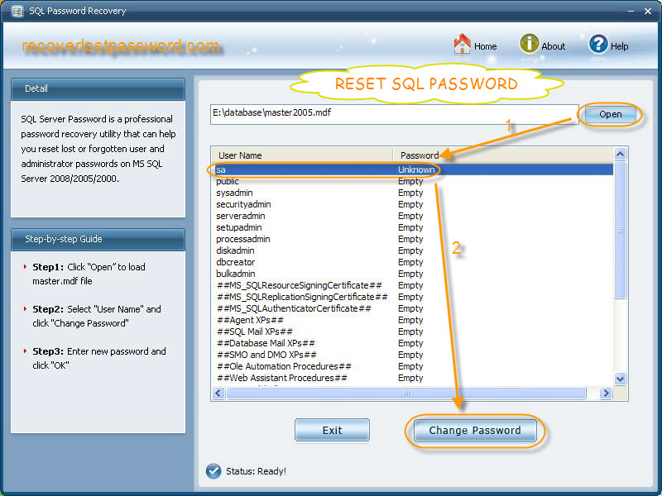

Step 2: Load files

Click on“Open”at the top of right corner to import .mdf files from your computer directly. All the information about your SQL server account will be on the list. Here you should select “sa” and hit “change password”.

Tips: No need to install Microsoft SQL Server, this is the highlight of this SQL Password Cracker compared with other third-party utility.

Step 3: Reset SQL password

A password reset case appears, you need to type your new SA password twice.

Tips: 1.You had better mix different types of characters. Strong password is consist of upper case letters, lower case, numbers and special characters.
2. The minimum length for a strong password is 12 characters; of course, the longer, the better.

Yes, it’s true. You have reset SQL password successfully. Quite simple, the whole procedure just takes you one minute.

